Initial setup
General description of our configuration for general public.
Actually, such a lab environment could be configured in 5-10 minutes.

Zywall 310
LAN: 10.8.2.0/24
WAN: ….
Tunnel1 (GRE to WAN of Zywall 110):10.8.131.1/29
IPSec tunnel (IPSec between WAN interfaces of GWs) – initially inactivated
Phase 1 - PSK, AES256, SHA512, DH5
Phase 2 – Nailed up, Site-to-site, Enable GRE over IPSec, ESP, Tunnel, DES, SHA1, DH2
BGP: AS number – 64500, router ID - 10.8.131.1 , Redestribute – Off, neighbors - 10.8.131.2/ 64501, enable EBGP Multihop, Announcing networks - 192.168.0.0/16 & 10.0.0.0/8

Zywall 110
LAN: 10.8.3.0/24
WAN: ….
Tunnel1: (GRE to WAN of Zywall 310):10.8.131.2/29
IPSec tunnel (IPSec between WAN interfaces of GWs) – initially inactivated:
Phase 1 - PSK, AES256, SHA512, DH5
Phase 2 – Nailed up, Site-to-site, Enable GRE over IPSec, ESP, Tunnel, DES, SHA1, DH2
BGP: AS number – 64501, router ID - 10.8.131.2 , Redestribute – Off, neighbors - 10.8.131.1/ 64501, enable EBGP Multihop, Announcing networks - 10.8.3.0/24

Experiment 1: Un-encrypted GRE with BGP support

- Implement configurations: 310_Experimental1.conf & 110_Experimental1.conf respectively.
(Sorry, I cannot share my conf files to general public, because I got them from a productive environment)

- SSH to '310 gw

- Ping from 310 to 110 works fine:
Router310# ping 10.8.131.2
PING 10.8.131.2 (10.8.131.2) 56(84) bytes of data.
64 bytes from 10.8.131.2: icmp_seq=1 ttl=64 time=5.06 ms
64 bytes from 10.8.131.2: icmp_seq=2 ttl=64 time=4.87 ms
64 bytes from 10.8.131.2: icmp_seq=3 ttl=64 time=4.64 ms

- Check for BGP connectivity and announcing on 310:

Router310# show bgp summary
Neighbor AS MsgRcvd MsgSent TblVer InQ OutQ Up/Down State/PfxRcd
===============================================================================
10.8.131.2 64501 8 9 0 0 0 00:04:49 Established

Router310# show ip route bgp
Flags: A - Activated route, S - Static route, C - directly Connected
O - OSPF derived, R - RIP derived, B - BGP derived, G - selected Gateway
! - reject, H - Black hole, L - Loop

IP Address/Netmask Gateway IFace Metric Flags Persist
===============================================================================
10.8.3.0/24 10.8.131.2 tunnel1 0 ABG 0000h:07m:48s

- Connect to the opposite gw through the tunnel interface:

Router310# ssh admin@10.8.131.2
The authenticity of host '10.8.131.2 (10.8.131.2)' can't be established.
RSA key fingerprint is b2:e3:58:d7:49:4a:d6:e2:7b:f9:7b:f6:a1:8e:5a:fc.
Are you sure you want to continue connecting (yes/no)? yes
Warning: Permanently added '10.8.131.2' (RSA) to the list of known hosts.
Password:

- Check for BGP connectivity and announcing on 110:
Router110> enable
Router110# show bgp summary
Neighbor AS MsgRcvd MsgSent TblVer InQ OutQ Up/Down State/PfxRcd
===============================================================================
10.8.131.1 64500 14 16 0 0 0 00:11:04 Established

Router110# show ip route bgp
Flags: A - Activated route, S - Static route, C - directly Connected
O - OSPF derived, R - RIP derived, B - BGP derived, G - selected Gateway
! - reject, H - Black hole, L - Loop

IP Address/Netmask Gateway IFace Metric Flags Persist
===============================================================================
10.0.0.0/8 10.8.131.1 tunnel1 0 ABG 0000h:11m:19s
192.168.0.0/16 10.8.131.1 tunnel1 0 ABG 0000h:11m:19s

- Check for routing between some hosts on LANs of 310 and 110:
C:\Windows\system32>ipconfig

Windows IP Configuration

Ethernet adapter Ethernet:

Connection-specific DNS Suffix . :
IPv4 Address. . . . . . . . . . . : 10.8.2.10
Subnet Mask . . . . . . . . . . . : 255.255.255.0
Default Gateway . . . . . . . . . : 10.8.2.254

C:\Windows\system32>ping 10.8.3.115

Pinging 10.8.3.115 with 32 bytes of data:
Reply from 10.8.3.115: bytes=32 time=4ms TTL=126
Reply from 10.8.3.115: bytes=32 time=4ms TTL=126
Reply from 10.8.3.115: bytes=32 time=12ms TTL=126
Reply from 10.8.3.115: bytes=32 time=17ms TTL=126

Ping statistics for 10.8.3.115:
Packets: Sent = 4, Received = 4, Lost = 0 (0% loss),
Approximate round trip times in milli-seconds:
Minimum = 4ms, Maximum = 17ms, Average = 9ms

So, un-encrypted GRE with BGP support works fine!!!

Experiment 2: GRE over IPSEC. BGP does not work.
- Implement configurations: 310_Experimental2.conf & 110_Experimental2.conf respectively.
Or
Just activate IPSec VPN rules "Domodedovo_GRE_over_IPSec" and "Greenwood_GRE_over_IPSec" on 310 and 110 respectively and put down and up tunnel interfaces on both routers to re-establish GRE tunnel through IPSec.

- Ping from 310 to 110 works fine:
Router310# ping 10.8.131.2
PING 10.8.131.2 (10.8.131.2) 56(84) bytes of data.
64 bytes from 10.8.131.2: icmp_seq=1 ttl=64 time=5.06 ms
64 bytes from 10.8.131.2: icmp_seq=2 ttl=64 time=4.87 ms
64 bytes from 10.8.131.2: icmp_seq=3 ttl=64 time=4.64 ms

- Check for BGP connectivity and announcing on 310:
Router310# show bgp summary
Neighbor AS MsgRcvd MsgSent TblVer InQ OutQ Up/Down State/PfxRcd
===============================================================================
10.8.131.2 64501 35 39 0 0 0 00:03:25 Connect

Router310# show ip route bgp
Flags: A - Activated route, S - Static route, C - directly Connected
O - OSPF derived, R - RIP derived, B - BGP derived, G - selected Gateway
! - reject, H - Black hole, L - Loop

IP Address/Netmask Gateway IFace Metric Flags Persist
===============================================================================

- Try to SSH from 310 to 110:
Router310# ssh admin@10.8.131.2
ssh: connect to host 10.8.131.2 port 22: Connection timed out

- Check for BGP connectivity and announcing on 110:
Router310# show bgp summary
Neighbor AS MsgRcvd MsgSent TblVer InQ OutQ Up/Down State/PfxRcd
===============================================================================
10.8.131.1 64500 34 39 0 0 0 00:01:17 Connect

Router# show ip route bgp
Flags: A - Activated route, S - Static route, C - directly Connected
O - OSPF derived, R - RIP derived, B - BGP derived, G - selected Gateway
! - reject, H - Black hole, L - Loop

IP Address/Netmask Gateway IFace Metric Flags Persist
===============================================================================

AT THIS POINT WE HAVE STATED A PROBLEM WITH NO SOLUTION

Additional experiments:

- Packet capture:
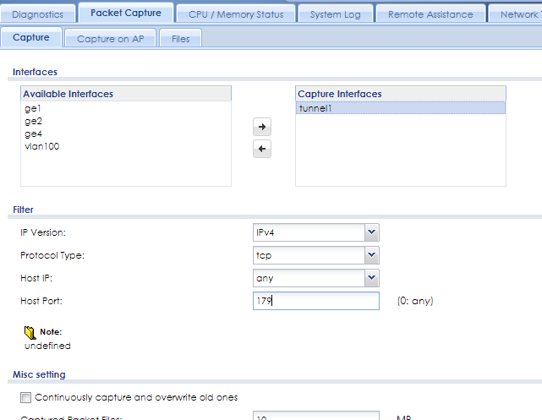

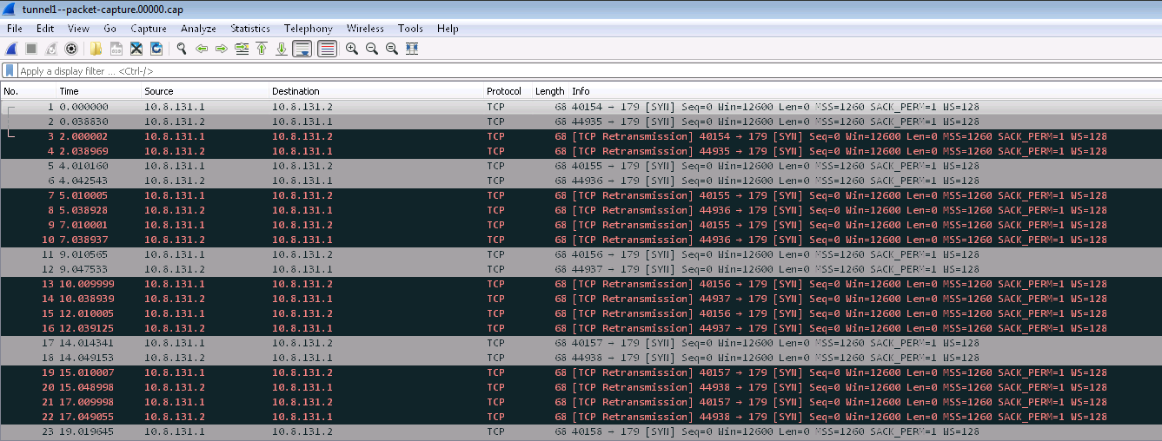

- Route the traffic using Policy route:
Activate policy route #1 on BOTH 310' and 110' GWs.

Check for routing status:
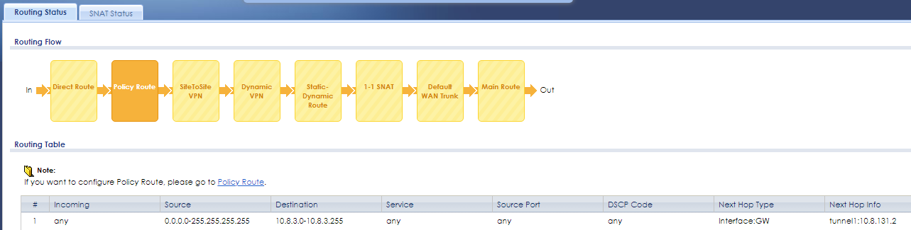

And check for routing between some hosts on LANs of 310 and 110:
C:\Windows\system32>ipconfig

Windows IP Configuration

Ethernet adapter Ethernet:

Connection-specific DNS Suffix . :
IPv4 Address. . . . . . . . . . . : 10.8.2.10
Subnet Mask . . . . . . . . . . . : 255.255.255.0
Default Gateway . . . . . . . . . : 10.8.2.254

C:\Windows\system32>ping 10.8.3.115

Pinging 10.8.3.115 with 32 bytes of data:
Reply from 10.8.3.115: bytes=32 time=4ms TTL=126
Reply from 10.8.3.115: bytes=32 time=4ms TTL=126
Reply from 10.8.3.115: bytes=32 time=12ms TTL=126
Reply from 10.8.3.115: bytes=32 time=17ms TTL=126

Ping statistics for 10.8.3.115:
Packets: Sent = 4, Received = 4, Lost = 0 (0% loss),
Approximate round trip times in milli-seconds:
Minimum = 4ms, Maximum = 17ms, Average = 9ms

