Firmware Recovery
In some rare sitiuation(symptom as following), ZyWALL Firewall might not boot up successfully after firmware upgrade. The following procedures are the steps to recover firmware to normal condition. Please connect console cable to ZyWALL Firewall.

- Symptom:
- Booting success but device show error message “can’t get kernel image” while device boot.
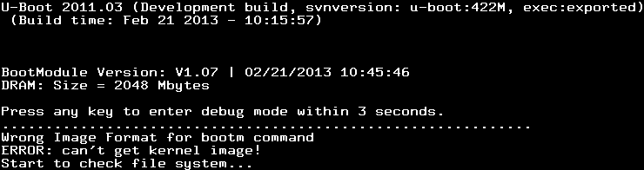
- Device reboot infinitely.
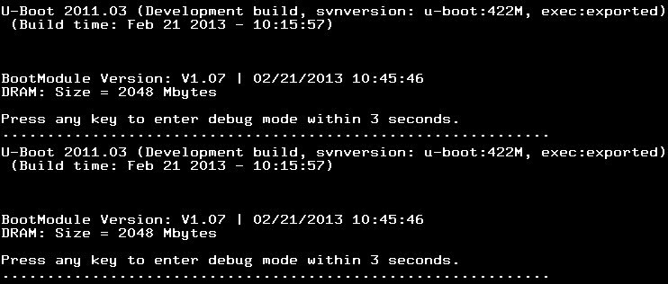
- Nothing displays after “Press any key to enter debug mode within 3 seconds.” for more than1 minute.
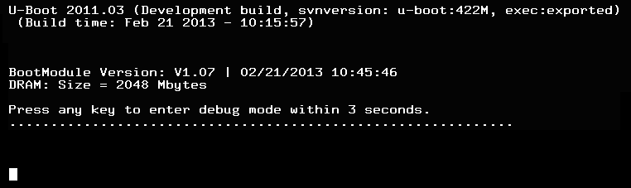
- Startup message displays “Invalid Recovery Image”.
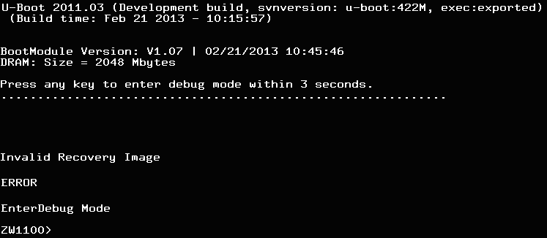
- The message here could be “Invalid Firmware”. However, it is equivalent to “Invalid Recovery Image”.
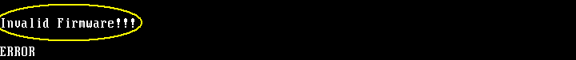
- Recover steps
- Press any key to enter debug mode
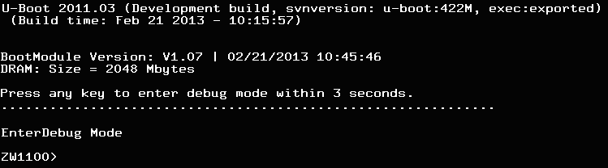
- Enter atkz –f –l 192.168.1.1 to configure FTP server IP address
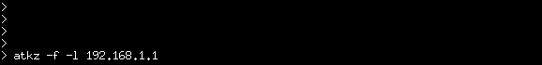
- Enter atgof to bring up the FTP server on port 2
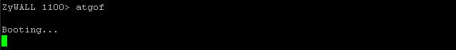

- The following information shows the FTP service is up and ready to receive FW
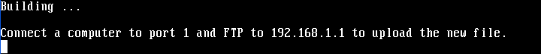
- You will use FTP to upload the firmware package. Keep the console session open in order to see when the firmware update finishes.
- Set your computer to use a static IP address from 192.168.1.2 ~ 192.168.1.254. No matter how you have configured the ZyWALL Firewall’s IP addresses, your computer must use a static IP address in this range to recover the firmware.
- Connect your computer to the ZyWALL Firewall’s port 2 (the only port that you can use for recovering the firmware).
- Use an FTP client on your computer to connect to the ZyWALL Firewall. This example uses the ftp command in the Windows command prompt. The ZyWALL Firewall’s FTP server IP address for firmware recovery is 192.168.1.1
- Log in without user name (just press enter).
- Set the transfer mode to binary. Use “bin” (or just “bi” in the Windows command prompt).
- Transfer the firmware file from your computer to the ZyWALL Firewall (the command is “put 310AAAC0C0.bin” in the Windows command prompt).
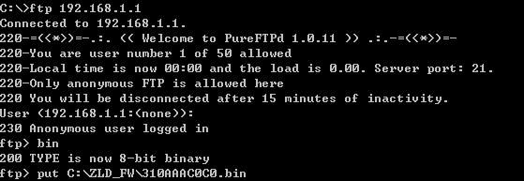
- Wait for the file transfer to complete.
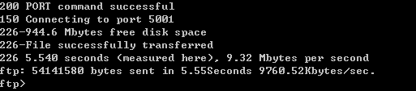
- The console session displays “Firmware received” after the FTP file transfer is complete. Then you need to wait while the ZyWALL Firewall recovers the firmware (this may take up to 4 minutes).
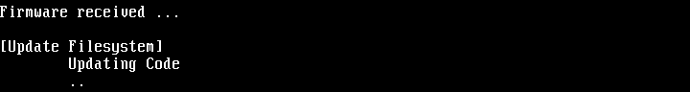
- The message here might be “ZLD-current received”. Actually, it is equivalent to “Firmware received”.
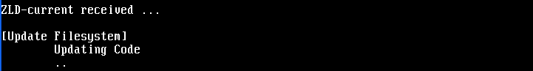
- The console session displays “done” when the firmware recovery is complete. Then the ZyWALL Firewall automatically restarts.
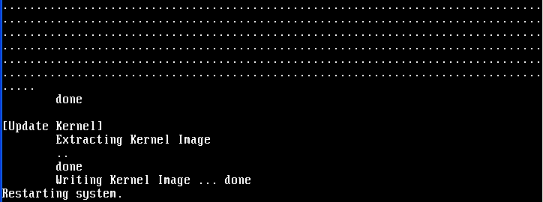
- The username prompt displays after the ZyWALL Firewall starts up successfully. The firmware recovery process is now complete and the ZyWALL Firewall is ready to use.
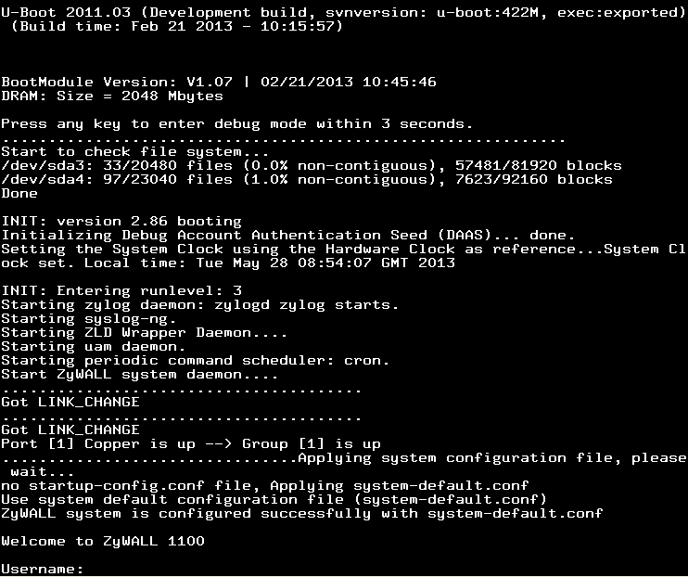

- If one of the following cases occurs, you need to do the “firmware recovery process” again. Note that if the process is done several time but the problem remains, please collect all the console logs and send to ZyXEL/USG for further analysis.
    - One of the following messages appears on console, the process must be performed again ./bin/sh: /etc/zyxel/conf/ZLDconfig: No such file
Error: no system default configuration file, system configuration stop!!

